PINETOWN DISTRICT

June
Examination
2025

Grade 12
Information Technology P2

2019

Marks: 150 Time: 3 hours

This question paper consists of 15 pages including the cover page.

INSTRUCTIONS AND INFORMATION
1. | This question paper consists of SIX sections:
  Section A: | Short questions | (20)
  Section B: | System Technologies | (25)
  Section C: | Communication and Network Technologies | (24)
  Section D: | Data and Information Management | (23)
  Section E: | Solution Development | (21)
  Section F: | Integrated Scenario | (37)
2. | Read ALL the questions carefully.
3. | Answer ALL the questions.
4. | The mark allocation generally gives an indication of the number of facts/reasons required.
5. | Number the answers correctly according to the numbering system used in this question paper.
6. | Write neatly and legibly.

SECTION A: SHORT QUESTIONS
QUESTION ONE
1. 1 Multiple choice : Various options are given as possible answers to the
following questions. Choose the correct answer and write only the letter
(A–D) next to the question number (1.1.1–1.1.10) in your answer book.
1.1.1 Linux is an example of … software, which means its code is provided free for use, modification and redistribution.
A) Proprietary.
B) Shrink-wrapped.
C) Open-source.
D) Virtual.

1.1.2 Which data type for variable x in the following expression is CORRECT?
x := 13 mod 3 =0;
A) Integer
B) Real
C) Boolean
D) Char

1.1.3 A process where a single program is broken up into multiple parts that can be processed simultaneously and independently:
A) Multiflow.
B) Multithreading.
C) Multitasking.
D) Multiprocessing.

1.1.4 … refers to the simulation of human thinking in machines that are programmed to think like humans and mimic their actions.
A) A simulator
B) A learning algorithm
C) Artificial intelligence
D) Human-computer interaction

1.1.5 A programming language used exclusively for manipulating data in a database:
A) SQL.
B) AJAX.
C) DELPHI.
D) PHP.
1.1.6 What value will be displayed?
iCount ← 9
While iCount < 10 do
iCount ← iCount +1
End While
Display iCount
A) 9
B) 10
C) 11
D) Nothing will be displayed.

1.1.7 The process of discovering new patterns in data using sophisticated software is known as …
A) data warehousing.
B) information processing.
C) big data.
D) data mining.

1.1.8 What is the role of a compiler in software development?
A) Updates and adds source code.
B) Encrypts and decrypts source code.
C) Compresses source code files.
D) Translates source code into machine language.

1.1.9 The instance of a class in OOP is called a/an …
A) object.
B) attribute.
C) method.
D) data type.

1.1.10 Embedded wires that allow data to travel in and out of the CPU are called …
A) bridges.
B) arrays.
C) streams.
D) buses.

 | (10 x 1) | (10)
1.2 Give ONE word/term for each of the following descriptions. Write only the word/term next to the question numbers (1.2.1 to 1.2.10)
1.2.1 | A creator’s exclusive legal right to reproduce, publish or sell intellectual property. | (1)
1.2.2 | An identity theft scam where the user is automatically redirected to another fake website even if the correct URL was entered. | (1)
1.2.3 | The ability of a system to increase or decrease its resources depending on the number of users. | (1)
1.2.4 | A category of software specifically designed to perform various tasks and functions for end-users. | (1)
1.2.5 | A data structure that stores a set of values of the same data type. | (1)
1.2.6 | A peer-to-peer protocol used for downloading and uploading large files over the internet. | (1)
1.2.7 | The efficient and environmentally responsible design and disposal of computer equipment. | (1)
1.2.8 | Storage space used by the operating system when there is insufficient RAM. | (1)
1.2.9 | The study and design of computer equipment to enhance the comfort and safety of the user. | (1)
1.2.10 | A program that enables the operating system to communicate with a device. | (1)
 | (10 x 1) | (10)
TOTAL SECTION A: |  | [20]

SECTION B: SYSTEM TECHNOLOGIES
QUESTION TWO
2.1 | A motherboard houses and connects the components of a computer.
 | 2.1.1 | What is the component on the motherboard called that houses the CPU? |  | (1)
 | 2.1.2 | Explain why a point-to-point connection is used to connect the CPU to the RAM, rather than a bus as used for other components. |  | (2)
 | 2.1.3 | Define multiprocessing. |  | (2)
2.2 | Caching offers advantages to users, network systems and businesses.  Briefly explain what caching is. |  |  | (2)
2.3 | Laptops come equipped with either a HDD or an SSD
 | 2.3.1 | Users of laptops equipped with HDDs are advised to defragment the HDD regularly.  Briefly explain what defragmentation is. |  | (2)
 | 2.3.2 | Write out the abbreviation SSD in full. |  | (1)
 | 2.3.3 | Explain why an SSD accesses the data faster than a HDD. |  | (2)
2.4 | There is noticeable increase in unauthorised access to computers and programs. What can be done to prevent unauthorised access to software at the centre? |  |  | (1)
2.5 | Mobile technologies have revolutionised the computing world. Some software is designed for use on mobile devices.
 | 2.5.1 | Give TWO limitations related to the use of mobile devices when compared to devices such as PCs and laptops. |  | (2)
 | 2.5.2 | Smartphones have the functions and abilities of many different devices built into a single device. What is the term used for this design approach? |  | (1)
2.6 | Software as a Service (SaaS) is currently becoming a popular option for using software.
 | 2.6.1 | Except for the benefit of renting instead of buying software, state TWO other benefits of using SaaS. |  | (2)
 | 2.6.2 | Some software that we use requires us to have a licence.  Motivate why acquiring a site licence is better than acquiring a single-user licence for each of the users. |  | (2)
2.7 | Critical to the success of any business / institution is ensuring no downtime and that regular backups of important data are made.
 | 2.7.1 | Explain what a backup strategy is and how it can help prevent downtime. |  | (3)
 | 2.7.2 | A cloud storage service could be used to backup data off-site.  State TWO disadvantages of using cloud storage to backup data off-site. |  | (2)
TOTAL SECTION B: |  |  |  | [25]

SECTION C: COMMUNICATION AND NETWORK TECHNOLOGIES
QUESTION 3
3.1 | Study the scenario below and answer the questions that follow:  A company has offices in Cape Town and Johannesburg. They use a WAN to connect these branches and rely on fibre-optic cables for high-speed data transfer.
 | (a) Define the term WAN. | (2)
 | (b) State TWO advantages of using fibre-optic cables over copper cables. | (2)
 | (c) Name ONE other wired transmission medium besides fibre-optic cables. | (1)
3.2 | A school’s IT administrator is setting up a wireless network for students.  A firewall is essential in a network to safeguard against breaches in security.
 | (a) Name TWO other types of security measures that can be used to safeguard your data on a network. | (2)
 | (b) Explain ONE risk of using an unsecured public Wi-Fi network. | (2)
3.3 | BitTorrent is a peer-to-peer (P2P) file-sharing protocol.
 | - Explain how BitTorrent differs from traditional client-server downloading. | (3)
 | - Discuss ONE ethical concern related to the use of BitTorrent. | (2)
3.4 | A business experiences frequent network downtime.
 | (a) Suggest TWO possible causes of network downtime | (2)
 | (b) Recommend ONE strategy to improve network reliability | (2)
3.5 | Explain the role of DNS (Domain Name System) in internet communication. | (3)
3.6 | Briefly discuss how a VPN (Virtual Private Network) enhances security for remote workers. | (3)
 | TOTAL SECTION C: | [24]

SECTION D: DATA AND INFORMATION MANAGEMENT
QUESTION 4

4.1 | Provide a brief description of a Flat file database |  |  | (1)
4.2 | Data warehouses use Flat file databases to store data. What is a data warehouse? |  |  | (2)
4.3 | A database needs to be protected from different threats that may arise. Provide TWO tools that can be used to protect the data. |  |  | (2)
4.4 | A company called Bob’s Bus Boys has a database to store details of available buses and bus drivers. TblBuses stores all the details of the buses and tblDrivers stores all the details of the bus drivers’.
tblBuses
Field Name | Data Type | Field Size | Description
BusID | AutoNumber |  | Primary Key
Make | ShortText | 25 | Make of the bus
Model | ShortText | 25 | Model of the bus
ServiceDate | ShortText |  | Date the bus had its last service
Mileage | Number |  | Mileage on the odometer
Route | ShortText | 30 | The route the bus takes
DriverID | ShortText | 5 | The driverID from tblDrivers FK

tblDrivers
Field Name | Data Type | Field Size | Description
DriverID | ShortText | 4.1.1 a | Primary Key
DriverName | ShortText | 25 | Name of the bus driver
DriverSurname | ShortText | 25 | Surname of the bus driver
ContactNo | ShortText | 4.1.1 b | Cell phone number of the bus driver
DriverLicence | Yes/No |  | Does the driver have a valid driver’s licence

 | 4.4.1 | Provide an appropriate field size for  4.4.1 a. DriverID  4.4.1.b. ContactNo |  | (2)
 | 4.4.2 | A relation needs to be done for the database. Draw an ER diagram showing the type of relationship that exists and the linked fields |  | (3)
 | 4.4.3 | One of the fields has an unsuitable data type. Identify this field and indicate the data type it should have. |  | (2)
 | 4.4.4 | The fields BusID and DriverID are indicated as primary keys in tblBuses and tblDrivers respectively.  Explain the significance of a primary key. |  | (1)
 | 4.4.5 | Provide a brief description of a Composite Key |  | (1)
 | 4.4.6 | Provide another field name in tblDrivers that can be used as a primary key |  | (1)
4.5 | The business would like to protect their database from data loss. A technician told them to make use of disk RAID.  Define the term disk RAID |  |  | (2)
4.4 | An audit trail was setup to maintain the integrity of the database.  State the basic information that is captured in the audit trail. |  |  | (3)
4.5 | What can be done to a database to ensure that no data anomalies can occur? |  |  | (1)
4.6 | Name TWO anomalies that can occur in a database. |  |  | (2)
 | TOTAL SECTION D: |  |  | [23]

SECTION E: SOLUTION DEVELOPMENT
QUESTION 5
5.1 There are many types of errors that can occur in software development.
5.1.1 Differentiate between a syntax error and a runtime error. (2)
5.1.2 What is the base number of the binary number system? (1)

5.2 Arrays are frequently used to store data in a program.
5.2.1 When does it become necessary to use an array instead of a
variable? (1)
5.2.2 The names and ages of learners must be stored in an array.
arrNum : array [1..30] of Integer;
Motivate why the names and ages cannot be stored in the array
provided. (1)
5.3 OOP is the abbreviation for object-oriented programming.
    - State whether the following statements are TRUE or FALSE:

- A toString method is used to change the value of an attribute
to a string for display purposes. (1)

- It is possible to instantiate an object without writing/creating
your own constructor method for the object class. (1)

- The number of parameters received in constructor must be
equal to the number of attributes of the object class. (1)
5.3.2 Differentiate between accessor method and mutator method. (2)
5.4
Segment of code to read from a file | Output:
Assignfile(tFile,'countries.txt'); | Sweden
Reset(tFile); | Italy
While not eof(tFile) do | Japan
begin | Germany
Readln(tFile,sCountry); | Greece
redOutput.Lines.Add(sCountry)
end;
CloseFile(tFile);

5.4.1 Explain the purpose of the Assignfile-statement with specific
reference to the two arguments tFile and ‘countries.txt’. (2)
5.4.2 Explain why an error will occur if the Reset(tFile) in the given code
Is replaced with Append(tFile). (2)
5.4.3 Explain why no output will be displayed if Reset(tFile) in the given code is replaced with Rewrite(tFile). (1)
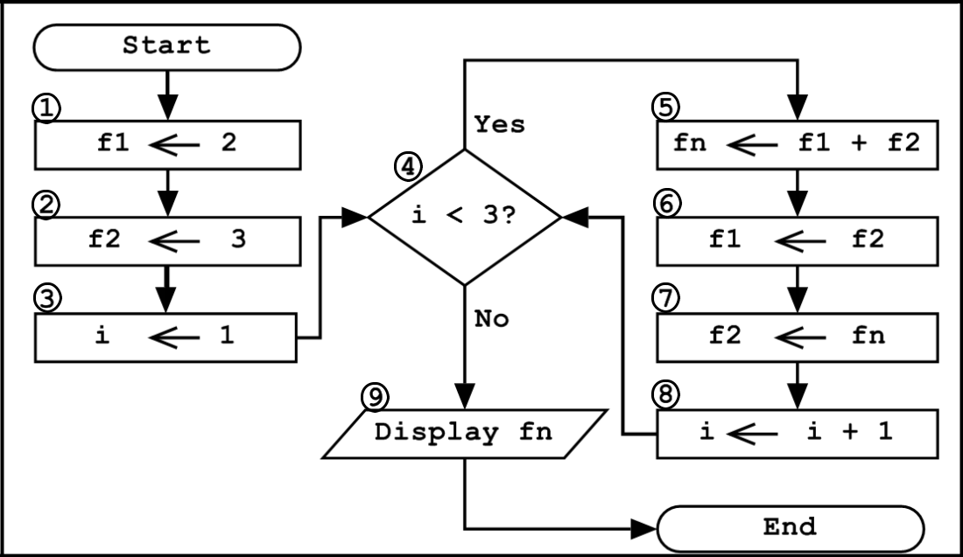
5.5

Redraw the following incomplete trace table into your ANSWER SHEET.
Complete the trace table by tracing step by step through the flowchart
above. (6)

Block No. | f1 | f2 | i | i < 3? | fn | Output
1 | 2
2 |  | 3
3 |  |  | 1

TOTAL SECTION E: [21]

SECTION F: INTEGRATED SCENARIO
QUESTION 6

6.1 A biometric access system has been installed for access control at the technology centre.

6.1.1 | Define the term biometric. | (2)
6.1.2 | State TWO possible biometric properties that could be used for
 | access control at the centre. | (2)

6.2 Many learners bring their mobile devices to school to use the hotspot at school.

6.2.1 | State ONE disadvantage of using a hotspot. | (1)
6.2.2 | Give TWO reasons why many well-known websites have specifically
 | developed apps that can be used on mobile devices. | (2)
6.2.3 | State TWO advantages of allowing the use of mobile devices at
 | school in terms of teaching and learning. | (2)
6.2.4 | Learners often use the hotspot to listen to music.
 | Give TWO reasons why learners would prefer to stream music
 | instead of downloading it. | (2)
6.2.5 | Learners are encouraged to use a media repository.
 | Explain what a media repository is. | (2)

6.3 A security consultant working at the company warns of security threats that employee computers will be exposed to, when connecting to the internet.
6.3.1 A rootkit was found on the server in the administration office.

(a) What is a rootkit? | (1)

(b) Give ONE security implication of the rootkit that installed itself on  the computer. | (1)

6.3.2 Social engineering is also a big concern regarding the privacy of employee data.

Define what social engineering entails. | (2)
6.3.3 How does antivirus software identify malware? | (1)

6.4 |  | The business is currently using a centralised database. They have been
 |  | advised to switch to a distributed database system.
 |  | Give TWO reasons why you would recommend that they do NOT switch to a
 |  | distributed database system. |  |  | (2)
6.5 |  | An employee was exploring the system settings on his/her computer and
 |  | encountered a screen displaying the following information:
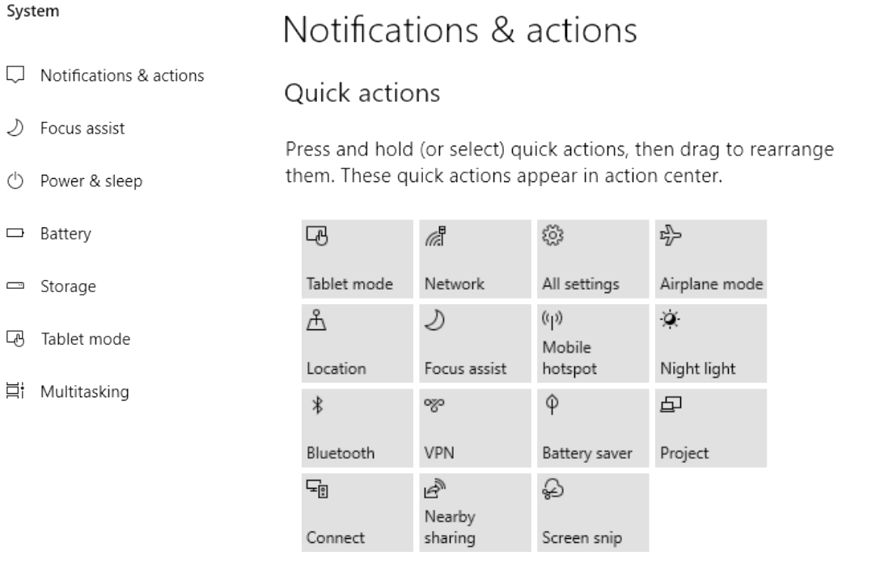

 |  | 6.5.1 | What is Nearby Sharing in Windows, and how does it facilitate file transfer between devices? | (2)
 |  | 6.5.2 | Indicate ONE option in the screenshot above that is related to green
 |  |  | computing. | (1)
 | 6.5.3 Define the term mobile hotspot. |  |  | (2)
 | 6.5.4 |  | (a) Briefly explain what multitasking is. | (2)
 |  |  | (b) How does multiprocessing differ from multitasking? | (2)
 | 6.5.5 Explain what nearby sharing in this context entails. |  |  | (1)
6.6 | As part of upgrading their ICT systems, the company considers cancelling
 | their landline in favour of using VoIP for communication with their customers.
 | State ONE possible disadvantages of relying solely on VoIP for
 | communication with customers. |  |  | (1)
6.7 | The company often needs to store food in their industrial fridges until it can be
 | shipped for exporting.
 | Make TWO recommendations on how Internet of Things (IoT) technology can
 | be used to ensure that the company does not suffer damage due to possible
 | problems with keeping the temperatures in their fridges at optimal levels. |  |  | (2)
6.8 | The company currently uses virtual reality as part of their advertising. They have now decided to make use of augmented reality in their adverts.
 | 6.8.1 |  | Briefly differentiate between virtual reality and augmented reality. | (2)
 | 6.8.2 |  | Provide an example of each. | (2)
 |  |  | TOTAL SECTION F: | [37]

TOTAL: [150]

